|  |  |
| --- | --- |
| **Sony Alpha A7C Camera**  Máy ảnh Sony Alpha A7C (Black) + Lens 28-60mm F/4-5.6 | Chính hãng  Sony A7C black with 28-60mm 1 Sony A7C black with 28-60mm 5 Sony A7C black with 28-60mm 3 Sony A7C black 6 | **Featured information:**   * Full-frame 24.2MP sensor * Continuous shooting at 10 frames/second * 693-point focus system * Articulating screen   Price: 2000$  **Specifications:**   * **Sensor Format:** Full-Frame (1x Crop Factor) * **Resolution:** 24.2 megapixels * **Size photo:** 6000 x 4000 * **Image Proportions:** 1:1, 3:2, 4:3, 16:9 * **Sensor Type:** CMOS * **Image Format:** JPEG, Raw * **Anti-Vibration:** Sensor-Shift, 5-Axis * **Lens Mount:** Sony E |

**Description:**

#### **SteadyShot Inside image stabilization technology**

Sony A7C uses 5-axis SteadyShot Inside image stabilization technology, providing effective anti-shake up to 5 stops, maximum support for both filming and photography needs. This technology helps users more confidently take handheld photos even when shooting with low shutter speeds, or using with third-party lenses via a mount adapter.

#### **Design of the Sony Alpha A7C camera**

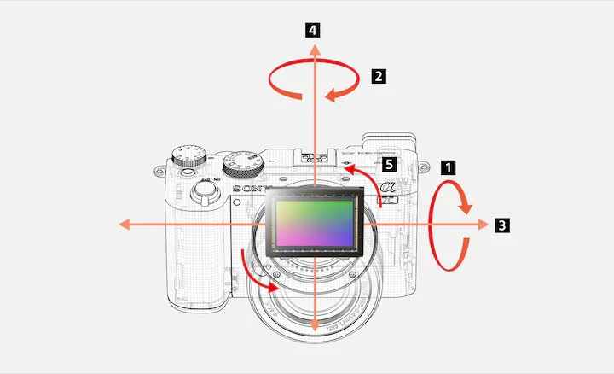

Sony Alpha A7C is equipped with a 24.2MP Full-frame Exmor R CMOS sensor with back-illuminated structure. Together with the BIONZ X image processor, this system improves image quality, delivers high resolution, reduces noise, and increases camera speed. The Sony A7C sensor also provides a high ISO sensitivity range of 100 - 51200 (expandable up to 50 - 204800).

